ORDER ENTRY RELEASE FOLDER STATUS CODES

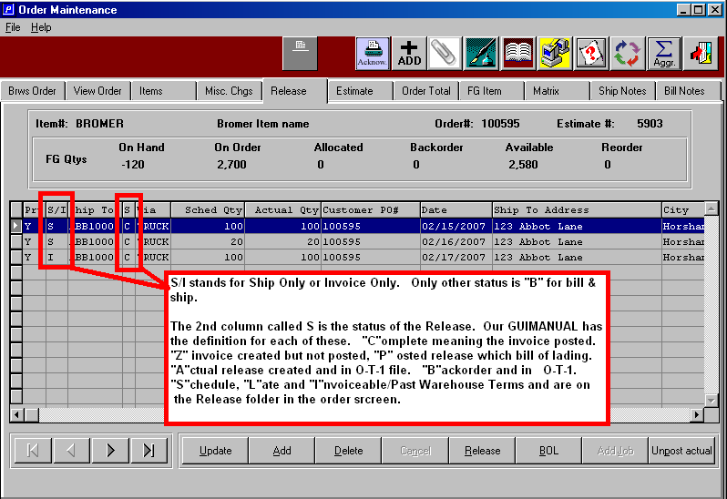

First, we like to refer to the Release Folder as the “Scheduled” Release Delivery Folder. Whereas the O-T-1 screens are normally actual releases scheduled for delivery. So under this definition, the O-U-1-Release Folder would have a future or planned delivery date, whereas O-T-1 are releases which would normally ship within days. Scheduled releases may have multiple shipping locations, multiple dates and multiple purchase order numbers for the same item on an order. When the N-K-1 OERELEAS parameter has the logical value set to YES, then the scheduled release is created when adding an order. The character value will dictate the date as the due date or last ship date when the release is created. This data will print on O-R-2, O-R-9 and O-R-12.

When adding new orders, the N-K-1-LASTHIP parameter dictates the due date and last ship date. If the character value is ASI, then the number of days defined in the customer filed field called Warehouse Days is added to the current order date to calculate both the due date and the last ship date. If the character value is FIBRE, then the due date is calculated by adding the integer value number of days is added to the order date to calculate the due date. The last ship date would still use the warehouse days. The philosophy behind the Last Ship Date was meant to be the contracted warehouse days that you will store the customers inventory before you can invoice him for the goods. Therefore, when the current date is 05/18/03 and the last ship date is 05/17/03 or earlier, the release status changes to an “I”nvoice warning status, providing the actual release has not been created. The e-Advantzware 24/7 customer service software will show this status as Past Warehouse Days in red.

Scheduled Release status codes may be “S”cheduled, “Late” or “I”nvoiceable. Actual Release codes are “A”ctual, “B”ackordered. Once the actual release has posted, the status changes to “P”osted and normally is found in the bill of lading file. Once the bill of lading is posted, the status changes to “Z” status for shipped complete and invoice created and is then found in the invoice file. If the bill of lading is partially shipped, the partial quantity release will have a status of “B”ackorder and will be found in O-T-1. When the invoice is posted, the release status changes to “C”. In summary the status codes:

S- Scheduled – Scheduled release based on date. Find in O-U-1-Release Folder.
L- Late – Late release. Current date past due date. Find in O-U-1-Release Folder
I- Invoice Now – Invoice release. Date past Last Ship date in O-U-1-Release Folder.
A- Actual – Actual release. Find in O-T-1 Actual release file.
P - Posted – Actual release Posted. Find in O-S-1 bill of lading file.
B- Backorder - Bill of Lading Posted. Find partial release in O-T-1.
Z- Completed - Bill of Lading Posted. Find in O-B-1 invoice file or invoice posted.
C- Invoiced - Invoice Posted . Must find in inquiries or Invoiced Releases.

PLEASE NOTE

N-K-1-LASTSHIP. Logic for calculating manufacturing days and last ship days. Character values FIBRE or ASI are used to calculate the default DUE DATE. ASI logic will create the due date and last ship date by adding the current date plus the warehouse days from customer file. When the character is Fibre, adding an order for a corrugated estimate or without an estimate will use the integer value as the default number of days to manufacture the boxes known as the default due date. For folding carton estimates, the integer value will be multiplied by the decimal value to determine the manufacturing days known as the due date. Hence if the decimal value were 2 and the integer value was 14, folding orders would add 28 days to the order date as the default due date. Clients that only produce corrugated boxes or only produce folding carton boxes should set the decimal value to 1.

When the N-K-1 LASTSHIP character value is FIBRE or ASI, the Last Ship date on the order is calculated by adding the customer’s warehouse days from the customer file to the
order date.

